Pages 29 - 39 in ***Java Programming A Comprehensive Introduction***

**Section 1: Define**

What is it mean to initialize a variable? – Initialize a variable means to give an arbitrary name that can be called later in the program. It has certain rules that we can start with lower case and must define the type as we declare the variable and name should not have any space.

Code block- a block of code is a section of code that are grouped together and set to work.

What is the purpose of a loop in programming? – keeps working certain block of code up to desired number of times.

loop- execute one or more block of code repeatedly.

**for** ( initialization; loop control condition; iteration) {

Loop Code Block; }

loop control variable- are

1. . Initializing the loop,
2. . testing the ending condition, and

3. changing the condition that is tested,

Operators

**++** Increment by one

write a very short example of code that can replace ++ (use any variable name you like.)

int variable = 0;

variable = variable + 1; note, instead of ++

**--** Decrease by one

write a very short example of code that can replace -- (use any variable name you like.)

int variable = 10;

variable = variable - 1; note, instead of --

**Programming Assignments**

Task 1-

(Conversion from miles to kilometers) Write a program that displays the following table. Keep the tab space formatting. (1 mile is 1.609 kilometers.) Please attach short whiteboard / pseudocode to display problem solving thought process.

Print a blank line every 5 lines.

Kilograms Pounds

1 1.609

2 3.218

3 ….(Conversion Value)

4 ….(Conversion Value)

5 ….(Conversion Value)

//Print Blank Line

6 ….(Conversion Value)

etc.

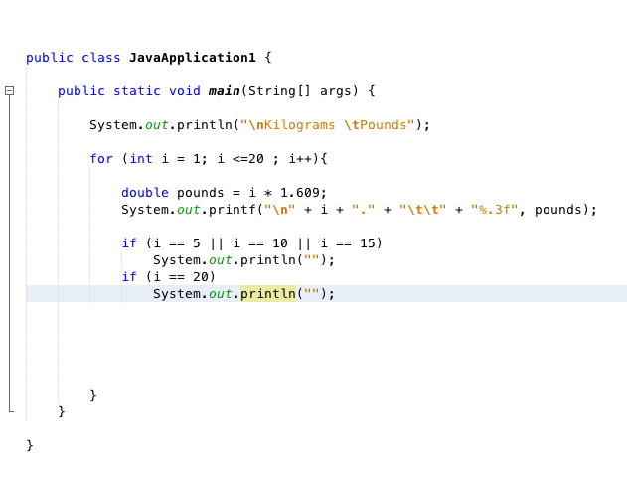

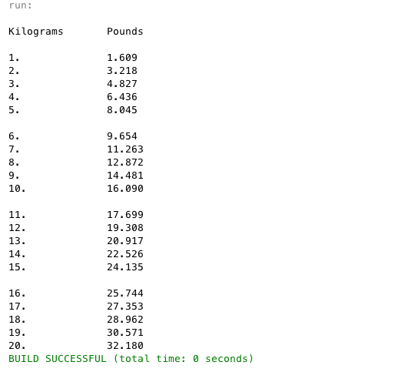

Note – I have used limited version of if statement to print space between 5 line, but in the second problem I have used universal statement of Boolean expression in if statement.

Task 2-

Pg. 41 # 29

Write a program that prints out the first 20 squared numbers**.** Starting at x = 1 until x = 20. **Do not use java.lang.Math**

Create a line counter variable that inputs a blank line every 5 lines.

Display outputs as shown below.

1 squared = 1

2 squared = 4

3 squared = 9

4 squared = 16

// Every 5 lines create a blank line.

5 squared = 25

6 squared = 36

7 squared = 49

Continued…

